WEEK 1 ASSIGNMENT

SOURCE CODE:

<!DOCTYPE html>

<html>

<head>

<title>Browser</title>

</head>

<body bgcolor="yellow">

<b>

To <br>

The Course Coordinator <br>

NIELIT Imphal

</b> <br> <br>

&nbsp &nbsp Sub: Request to take a leave

<p>

Sir,<br>

<p>

&nbsp &nbsp &nbspI want to take a leave on coming <ins>sunday</ins>.

Please give me the leave sir, i will be so grateful if you do so. <br><br>

Thank you so much sir.

</p>

<strong>Yours sincerely</strong>,<br>

<cite>Abhinash Toijam</cite><br>

<i>Roll no : BC 1953</i> <br>

Sec : A

</p>

</body>

</html>

Output:

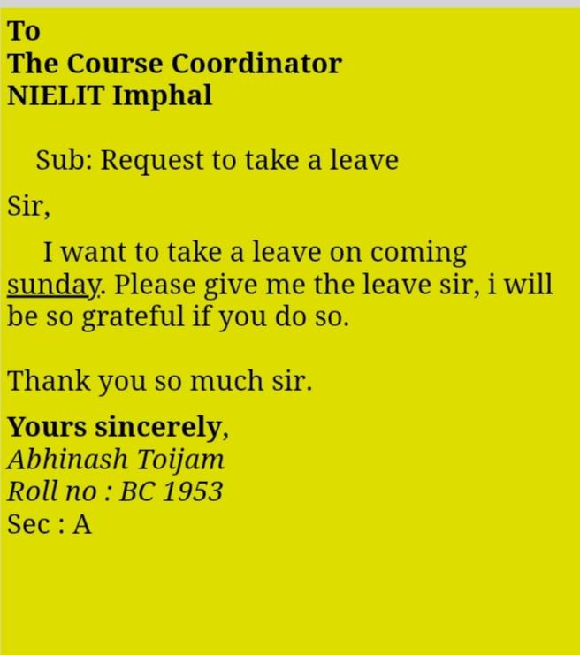

Submitted by:

Abhinash Toijam

BC 1953

Sec: A

BCA 4th semester